**Style Sheet** (ind.css)

**Code:**

#body {

    background-color: #212121;

    color: white;

}

#body {

    margin: 0;

    padding: 0;

}

ul {

    list-style-type: none;

    padding-top: 7px;

    padding-bottom: 30px;

    margin-bottom: 30px;

    border-top: 2px solid whitesmoke;

    background-color: #252525;

    box-shadow: 0px 5px 15px 3px rgb(23, 23, 23);

}

#anav {

    text-decoration: none;

    color: whitesmoke;

    font-family: Berlin Sans FB;

    font-size: 115%;

    padding: 5px 5px;

    padding-bottom: 7px;

}

#anav:hover {

    color: #12fff7;

    border-bottom: 3px solid #b3ffab;

    animation: navb 0.5s;

}

@keyframes navb {

    from {

        border-bottom: black;

        color: whitesmoke;

    }

    to {

        color: #12fff7;

        border-bottom: 3px solid #b3ffab;

    }

}

#he1 {

    font-family: forte;

    text-align: center;

    text-shadow: 1px 1px 50px whitesmoke;

    animation: welc 2s;

    padding-bottom: 20px;

}

@keyframes welc {

    from {

        color: #212121;

        text-shadow: 1px 1px 50px #212121;

        opacity: 0.5;

    }

    to {

        color: whitesmoke;

        text-shadow: 1px 1px 50px whitesmoke;

        opacity: 1;

    }

}

@keyframes pop2 {

    from {

        color: #333333;

    }

    to {

        color: whitesmoke;

    }

}

#secb {

    background-color: #333333;

    width: 100%;

    box-shadow: 8px 8px 20px rgb(23, 23, 23);

    padding: 8px 8px;

    border-radius: 9px;

}

#one {

    font-family: MV Boli;

    text-align: justify;

    font-size: 120%;

    padding: 10px 20px;

    border-radius: 5px;

    margin-right: 3px;

    background-color: #292929;

}

#ff {

    box-shadow: 0px -4px 15px 3px rgb(23, 23, 23);

    margin-top: 30px;

    padding-bottom: 20px;

    padding-top: 25px;

}

#foot1 {

    font-size: 20px;

    font-family: helvetica;

    color: whitesmoke;

}

.fa-facebook {

    color: #3978ff;

    /*color: white;*/

}

.fa-twitter {

    color: #5fbaff;

    /* color: white;*/

}

.fa-instagram {

    color: rgb(214, 67, 214);

}

.fa-linkedin {

    color: #007bb5;

}

.fa {

    padding-bottom: 10px;

    font-size: 25px;

    width: 40px;

    text-align: center;

    text-decoration: none;

    margin: 0px 2px;

}

.jack {

    height: 100%;

    width: 100%;

    background-color: #212121;

}

@keyframes example {

    from {

        opacity: 0.3;

    }

    to {

        opacity: 0.7;

    }

}

.form-box {

    width: 400px;

    height: 425px;

    position: relative;

    margin: 4% auto;

    background: #212121;

    padding: 5px;

    overflow: hidden;

}

.form-box2 {

    width: 600px;

    height: 450px;

    position: relative;

    margin: 4% auto;

    background: #212121;

    padding: 5px;

    overflow: hidden;

}

.button-box {

    width: 250px;

    margin: 30px auto;

    position: relative;

    border-radius: 30px;

    box-shadow: 0px 4px 15px 8px rgb(23, 23, 23);

}

.toggle-btn {

    padding: 10px 36px;

    cursor: pointer;

    background: transparent;

    border: 0;

    outline: none;

    position: relative;

    color: white;

    font-weight: bold;

}

#btn {

    top: 0;

    left: 0;

    position: absolute;

    width: 125px;

    height: 100%;

    background: linear-gradient(to right, #b3ffab, #12fff7);

    border-radius: 30px;

    transition: .5s;

    font-size: 100%;

    border: 3px solid #000;

}

.input-group {

    top: 10px;

    position: absolute;

    width: 280px;

    transition: .5s;

}

.input-field {

    width: 100%;

    padding: 10px 0;

    margin: 5px 0;

    border-left: 0;

    border-top: 0;

    border-right: 0;

    border-bottom: 1px solid #999;

    outline: none;

    background: transparent;

    color: whitesmoke;

}

.submit-btn {

    width: 35%;

    padding: 10px 30px;

    cursor: pointer;

    display: block;

    margin: auto;

    background: linear-gradient(to right, #b3ffab, #12fff7);

    border: 0;

    outline: none;

    border-radius: 30px;

    color: white;

}

.toggle-btn:focus,

.toggle-btn::selection {

    outline: none;

}

#login {

    left: 17px;

    width: 100%;

    display: flex;

}

#regis {

    left: 125px;

    width: 100%;

    display: flex;

}

.fgrp {

    display: flex;

    width: 700px;

}

#login input[type=email],

#regis input[type=text] {

    margin-top: 20px;

    margin-bottom: 10px;

}

#regis input[type=email] {

    margin-bottom: 10px;

}

#login input[type=submit] {

    margin-top: 50px;

}

#regis input[type=submit] {

    margin-top: 40px;

}

#supporttitle {

    text-align: center;

}

.wrap2 {

    display: flex;

    justify-content: center;

    align-items: center;

    flex-flow: column;

}

#but1:focus,

#but1::selection {

    outline: 0 !important;

    box-shadow: 0 0 0 0 rgba(0, 0, 0, 0) !important;

    border: none !important;

    border-color: transparent;

}

#but1 {

    background-color: #212121;

    color: whitesmoke;

    outline: 0 !important;

    box-shadow: 0 0 0 0 rgba(0, 0, 0, 0) !important;

    border: none !important;

    border-color: transparent;

}

#accordionExample {

    background-color: #212121;

    color: whitesmoke;

    outline: 0 !important;

    box-shadow: 0 0 0 0 rgba(0, 0, 0, 0) !important;

    border: none !important;

    border-color: transparent;

}

.accordion-body {

    background-color: #212121;

    outline: 0 !important;

    box-shadow: 0 0 0 0 rgba(0, 0, 0, 0) !important;

    border: none !important;

    border-color: transparent;

}

.accordion-button:not(.collapsed),

.accordion-button:not(.collapsed):focus {

    box-shadow: rgb(0 0 0 / 0%) 0px 0px 0px;

}

#moc1,

#moc2,#moc3,#moc4 {

    background-image: linear-gradient(to top, #b3ffab, #12fff7);

}

#mod1but,

#mod2but,

#mod3but,#mod4but {

    color: black;

}

#modal2ltitle,#modal3ltitle,#modal4ltitle {

    font-weight: bold;

    font-style: italic;

    color: #212121;

}

#bna {

    font-weight: bold;

    font-style: italic;

    color: #212121;

}

#tb1 {

    font-style: italic;

}

#tb1 tr th {

    color: #212121;

    font-weight: bolder;

}

#bbor {

    border-bottom: 1px solid #212121;

    border-radius: 15px;

    box-shadow: 0px 6px 6px 0px #212121;

}

#borret {

    font-size: 200%;

    text-shadow: 0px 0px 5px #212121;

    font-family: Matura MT Script Capitals;

    opacity: 0.7;

    border-color: #b3ffab;

    background-color: transparent;

    border-radius: 14px;

}

#borret:hover {

    opacity: 1;

}

#borret:not(.collapsed),

#borret:not(.collapsed):focus {

    box-shadow: rgb(0 0 0 / 0%) 0px 0px 0px;

}

#borrnum,#retnum {

    color: #212121;

    text-align: center;

    background-color: transparent;

    font-size: 125%;

    height:45px;

    margin-bottom: -15px;

    border-top:2px solid #000;

    border-left: 0;

    border-right: 0;

    border-bottom:2px solid #000;

    border-radius: 7px;

}

#borrnum:focus,

#borrnum::selection,#retnum:focus,

#retnum::selection {

    outline: none;

}

#borrnum::placeholder,#retnum::placeholder {

    color: grey;

    font-size: 90%;

    font-family: "Courier";

    padding: 20px;

}

#borsub,#retsub{

    background-color: transparent;

    border: 2px solid #000;

    border-radius: 20px;

    opacity: 0.7;

    font-weight: bold;

}

#borsub:hover,#retsub:hover{

    opacity: 1;

}

#baid{

    color: rgb(56, 56, 56);

    opacity: 0.8;

}

#baid span{

    color: #000;

}

#mutedtext{

    color: #333333;

    font-size: 80%;

}

#prompts {

    color: red;

}

#jaffa{

    margin-top:-25px;

}

#btor{

    border-top:2px solid #000;

    border-bottom:2px solid #000;

    border-radius: 15px;

}

**About us** (index.html)

**Code:**

<!DOCTYPE html>

<html lang="en">

<head>

<meta charset="UTF-8">

<meta http-equiv="X-UA-Compatible" content="IE=edge">

<meta name="viewport" content="width=device-width, initial-scale=1.0">

<link rel="stylesheet" href="https://cdn.jsdelivr.net/npm/bootstrap@4.4.1/dist/css/bootstrap.min.css"

integrity="sha384-Vkoo8x4CGsO3+Hhxv8T/Q5PaXtkKtu6ug5TOeNV6gBiFeWPGFN9MuhOf23Q9Ifjh" crossorigin="anonymous">

<link rel="icon" type="image/x-icon" href="https://www.logo.wine/a/logo/Apache_Tomcat/Apache_Tomcat-Logo.wine.svg">

<link rel="stylesheet" href="./css/ind.css">

<link rel="stylesheet" href="https://cdnjs.cloudflare.com/ajax/libs/font-awesome/4.7.0/css/font-awesome.min.css">

<title>OM3 Lib - About us</title>

<style>

</style>

</head>

<body id="body" class="container-fluid">

<header class="container-fluid">

<span>

<h1 class="mt-4 mb-4"

style="font-size:270%; font-family:Magneto; color:#b3ffab;margin-left:20px ; text-align:left;">

OM<sup><small>3</small></sup> Library <img width="130"

src="https://www.logo.wine/a/logo/Apache_Tomcat/Apache_Tomcat-Logo.wine.svg" align="right"

style="margin:-15px 5px" /></h1>

</span>

<!--<h3 style="color:white; font-family:Forte;"><i>Welcome USER,</i></h3>-->

</header>

<div>

<ul>

<li style="float:left;margin-left: -5px;">

<a id="anav" href="index.html">About us</a>

<!--welcome page address-->

</li>

<li style="float:right;margin-right: 40px;">

<a id="anav" href="logsig.php" title="Create new account / Sign in">Login / Sign up</a>

</li>

<li style="float:right;margin-right: 5px;cursor:default;">|</li>

<li style="float:right;margin-right: 5px;">

<a id="anav" href="support.php" target="_blank" title="Contact site">Support</a>

</li>

</ul>

</div>

<h1 id="he1">Welcome to OM<sup><small>3</small></sup></h1>

<div style="width: 100%;">

<div id="secb" align="left">

<div id="done">

<p id="one">

Are you a student struggling to get the right books for you assignment?

A home maker looking for Harry Potter Series for your child without putting a hole in your pocket?

A retired professional trying to develop a hobby of reading?

A professional looking to further your career by learning more?

The HR at your office hoping to encourage reading amongst your employees?

<br>&emsp;&emsp;If yes, you are at just the right place!<br>

OM<sup>3</sup> Library, AU north campus, Visakhapatnam provides access to over 20,000 books for all

age groups!

We allow a long borrowing time- 6 months to an year with 100% refundable deposit! Our wide range of

books will interest children,

students, NGOs, Corporates, professionals, retired personnel and many more.

From Paulo Coelho's Alchemist to Steven Covey's Seven Habits,

from Peter Drucker To Romila Thapar,

from Amitav Ghosh to J.K. Rowling; you will definately find the book of your interest!

You can surf the books through our specially designed Library Management System accessible over

internet if you are a member!

</p>

</div>

<div id="done">

<p id="one">

At OM<sup>3</sup> Library we want to get back the Joy of Reading!

We all have struggled to get that 'one' book to complete our work.

Be it a project, office assignment, or reading just for pleasure.

It is a challenge to get books at reasonable cost.

Readers usually have the option to either buy the books,

or rent it through a library and return within a short stipulated time.

OM<sup>3</sup> Library offers books free of cost against refundable deposit for 6 months to 1 year.

Free lending ensures access to everyone, even a reader who is not earning;

borrowing for longer duration enables reading at one's convenience and leisure.

With a busy and hectic lifestyles for most of us,

we hope these features bring back the joy of reading for everyone!

</p>

</div>

<div id="done">

<p id="one">

Our members have access to 20000 books - academic books on science, commerce, arts,

entrance examination preparations, fiction, non fiction and many more.

Extra copies of academic books which are high in demand are kept for larger benefit of students.

Get to know the details of our books and our inventory now!

Our quick & efficient Library Management System (LMS) ensures surfing of books online to save time.

As a member, you can look up the book you want, reserve it, come to the library and collect it

without wasting time.

We also prove access to online publications and journals at the library.

OM<sup>3</sup> Library provides these features coupled with with modern interiors,

air conditioning and an efficient LMS.

Membership can be availed by individuals, corporates, organisations, NGOs.

You can gift membership to that friend who is a bookworm too!

</p>

</div>

</div>

</body>

<footer style="background-color:#252525;">

<div id="ff" style="margin-top: 100px;">

<p id="foot1" align="middle">Contact us</p>

<div align="middle">

<a href="https://www.facebook.com/profile.php?id=100005647128902" target="_blank" title="Facebook"

class="fa fa-facebook"></a>

<a href="https://twitter.com/_v4vishnu_" target="_blank" class="fa fa-twitter" title="Twitter"></a>

<a href="https://www.instagram.com/_v4vishnu_/" target="_blank" class="fa fa-instagram"

title="Instagram"></a>

<a href="https://www.linkedin.com/in/vishnu-m-6092811a7/" target="_blank" class="fa fa-linkedin"

title="Linkedin"></a>

</div>

</div>

</footer>

</html>

**Output:**

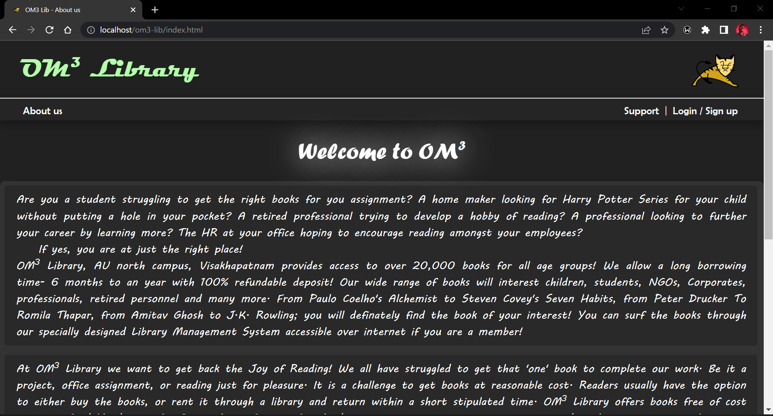

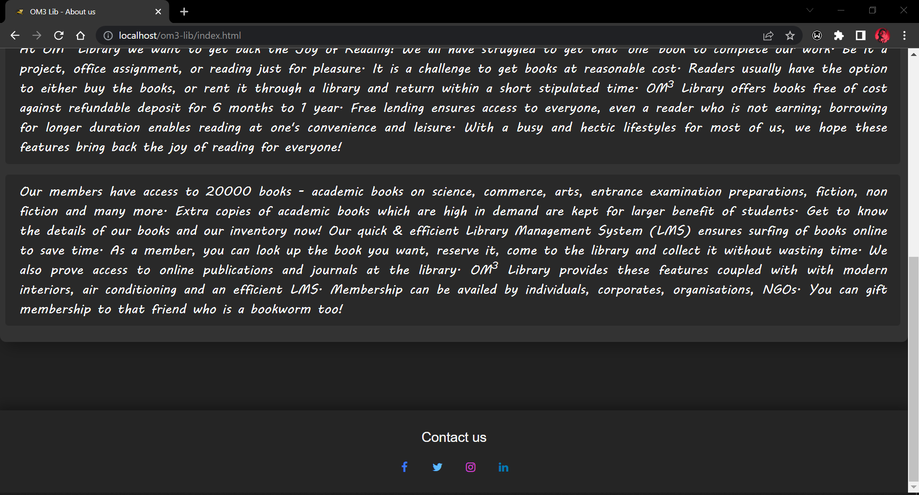

**Login and Signup** (logsig.php)

**Code:**

<?php

    $name = $email = '';

    $errors = array('uname' => '', 'eemail' => '');

    if (isset($_POST['signup'])) {

        $count = 1;

        $name = $_POST['userid'];

        if (empty($_POST['emailid'])) {

        } else {

            $email = $_POST['emailid'];

            $connect = new mysqli('sql6.freesqldatabase.com', 'sql6500064', 'k3rbF4wgQQ', 'sql6500064');

            $user_check_query = "SELECT * FROM logsig WHERE email='$email' LIMIT 1";

            $result = mysqli_query($connect, $user_check_query);

            //$user = mysqli_fetch_assoc($result);

            if ($result->num_rows > 0) {

                echo "<script>alert('Email already exists')</script>";

            } else {

                ++$count;

            }

        }

        $password = $_POST['passwrd'];

        if ($count == 2) {

            if ($connect->connect_error) {

                die('Connection Failed : ' . $connect->connect_error);

                $count = 1;

            } else {

                $regisresult = mysqli_query($connect, "INSERT INTO logsig(nameid,email,pass)values('$name','$email','$password')");

                echo "<script>alert('Registration Successful!')</script>";

                $name = $email = '';

                $connect->close();

                $count = 1;

                echo "<script>window.location.href='logsig.php';</script>";

            }

        }

    }

    session_start();

    $email = '';

    $errors = array('eemail' => '');

    if (isset($_POST['login'])) {

        $email = $_POST['emailid2'];

        $connect = new mysqli('sql6.freesqldatabase.com', 'sql6500064', 'k3rbF4wgQQ', 'sql6500064');

        $email_check_query = "SELECT * FROM logsig WHERE email='$email' LIMIT 1";

        $result1 = mysqli_query($connect, $email_check_query);

        $user = mysqli_fetch_assoc($result1);

        if ($result1->num_rows > 0) {

            $password = $_POST['passwrd2'];

            $pass_check_query = "SELECT * FROM logsig WHERE pass='$password' LIMIT 1";

           // echo "<script>alert('Login Successful!')</script>";

            $result2 = mysqli_query($connect, $pass_check_query);

            if ($result2->num_rows > 0) {

                $eemail_check_query = "SELECT * FROM logsig WHERE email='$email'";

                $res = mysqli_query($connect, $eemail_check_query);

                $resch = mysqli_num_rows($res);

                if ($resch > 0) {

                    while ($row = mysqli_fetch_assoc($res)) {

                        $_SESSION['idno'] = $row['id'];

                        $_SESSION['username'] = $row['nameid'];

                        $_SESSION['email'] = $row['email'];

                        $_SESSION['book']=$row['hold'];

                        $_SESSION['password'] = $row['pass'];

                    }

                }

                $email = '';

                echo "<script>window.location.href='home.php';</script>";

            } else {

                echo "<script>alert('Invalid username/password!')</script>";

            }

        }

    }

    ?>

<!DOCTYPE html>

<html lang="en">

<head>

    <meta charset="UTF-8">

    <meta http-equiv="X-UA-Compatible" content="IE=edge">

    <meta name="viewport" content="width=device-width, initial-scale=1.0">

    <link rel="stylesheet" href="https://cdn.jsdelivr.net/npm/bootstrap@4.4.1/dist/css/bootstrap.min.css" integrity="sha384-Vkoo8x4CGsO3+Hhxv8T/Q5PaXtkKtu6ug5TOeNV6gBiFeWPGFN9MuhOf23Q9Ifjh" crossorigin="anonymous">

    <link rel="icon" type="image/x-icon" href="https://www.logo.wine/a/logo/Apache_Tomcat/Apache_Tomcat-Logo.wine.svg">

    <link rel="stylesheet" href="./css/ind.css">

    <link rel="stylesheet" href="https://cdnjs.cloudflare.com/ajax/libs/font-awesome/4.7.0/css/font-awesome.min.css">

    <link rel="stylesheet" href="https://cdn.jsdelivr.net/npm/bootstrap@4.3.1/dist/css/bootstrap.min.css" integrity="sha384-ggOyR0iXCbMQv3Xipma34MD+dH/1fQ784/j6cY/iJTQUOhcWr7x9JvoRxT2MZw1T" crossorigin="anonymous">

    <script src="https://code.jquery.com/jquery-3.3.1.slim.min.js" integrity="sha384-q8i/X+965DzO0rT7abK41JStQIAqVgRVzpbzo5smXKp4YfRvH+8abtTE1Pi6jizo" crossorigin="anonymous">

    </script>

    <script src="https://cdn.jsdelivr.net/npm/popper.js@1.14.7/dist/umd/popper.min.js" integrity="sha384-UO2eT0CpHqdSJQ6hJty5KVphtPhzWj9WO1clHTMGa3JDZwrnQq4sF86dIHNDz0W1" crossorigin="anonymous">

    </script>

    <script src="https://cdn.jsdelivr.net/npm/bootstrap@4.3.1/dist/js/bootstrap.min.js" integrity="sha384-JjSmVgyd0p3pXB1rRibZUAYoIIy6OrQ6VrjIEaFf/nJGzIxFDsf4x0xIM+B07jRM" crossorigin="anonymous">

    </script>

    <title>OM3 Lib - Login/Signup</title>

</head>

<body id="body" class="container-fluid" style="animation-name: example;

animation-duration: 0.2s;

animation-iteration-count: 3;">

    <header class="container-fluid">

        <span>

            <h1 class="mt-4 mb-4" style="font-size:270%; font-family:Magneto; color:#b3ffab;margin-left:20px ; text-align:left;">

                OM<sup><small>3</small></sup> Library <img width="130" src="https://www.logo.wine/a/logo/Apache_Tomcat/Apache_Tomcat-Logo.wine.svg" align="right" style="margin:-15px 5px" /></h1>

        </span>

    </header>

    <ul>

        <li style="float:left;margin-left: -5px;">

            <a id="anav" href="index.html">About us</a>

        </li>

        <li style="float:right;margin-right: 40px;">

            <a id="anav" href="support.php" target="_blank" title="Sign in">Support</a>

        </li>

    </ul>

    <div style="width: 100%;">

        <div class="jack">

            <div class="form-box">

                <div class="button-box">

                    <div id="btn"></div>

                    <button type="button" class="toggle-btn" onclick="login()">Login</button>

                    <button type="button" class="toggle-btn" onclick="regis()">Sign up</button>

                </div>

                <div class="fgrp">

                    <form id="login" class="input-group" method="post" action="">

                        <input type="email" name="emailid2" class="input-field" placeholder="Enter mail" required>

                        <input type="password" name="passwrd2" class="input-field" placeholder="Enter password" required>

                        <input type="submit" name="login" class="submit-btn" value="Sign in">

                    </form>

                    <form id="regis" class="input-group" method="post" action="logsig.php">

                        <input type="text" class="input-field" value="<?php echo $name ?>" name="userid" placeholder="User ID" minlength="6" required>

                        <input type="email" class="input-field" value="<?php echo $email ?>" name="emailid" placeholder="Enter mail" required>

                        <input type="password" class="input-field" name="passwrd" placeholder="Enter password" minlength="6" required>

                        <input type="submit" name="signup" class="submit-btn" value="Sign up">

                    </form>

                </div>

            </div>

        </div>

    </div>

    <script>

        var x = document.getElementById("login");

        var y = document.getElementById("regis");

        var z = document.getElementById("btn");

        function regis() {

            x.style.left = '-450px';

            y.style.left = "-333px";

            z.style.left = "125px";

        }

        function login() {

            x.style.left = '17px';

            y.style.left = "117px";

            z.style.left = "0px";

        }

    </script>

</body>

<footer style="background-color:#252525;">

    <div id="ff">

        <p id="foot1" align="middle">Contact us</p>

        <div align="middle">

            <a href="https://www.facebook.com/profile.php?id=100005647128902" target="_blank" title="Facebook" class="fa fa-facebook"></a>

            <a href="https://twitter.com/_v4vishnu_" target="_blank" class="fa fa-twitter" title="Twitter"></a>

            <a href="https://www.instagram.com/_v4vishnu_/" target="_blank" class="fa fa-instagram" title="Instagram"></a>

            <a href="https://www.linkedin.com/in/vishnu-m-6092811a7/" target="_blank" class="fa fa-linkedin" title="Linkedin"></a>

        </div>

    </div>

</footer>

</html>

**Output:**

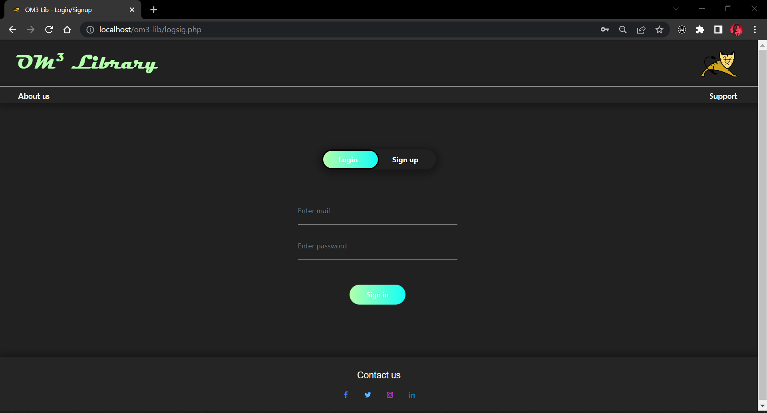

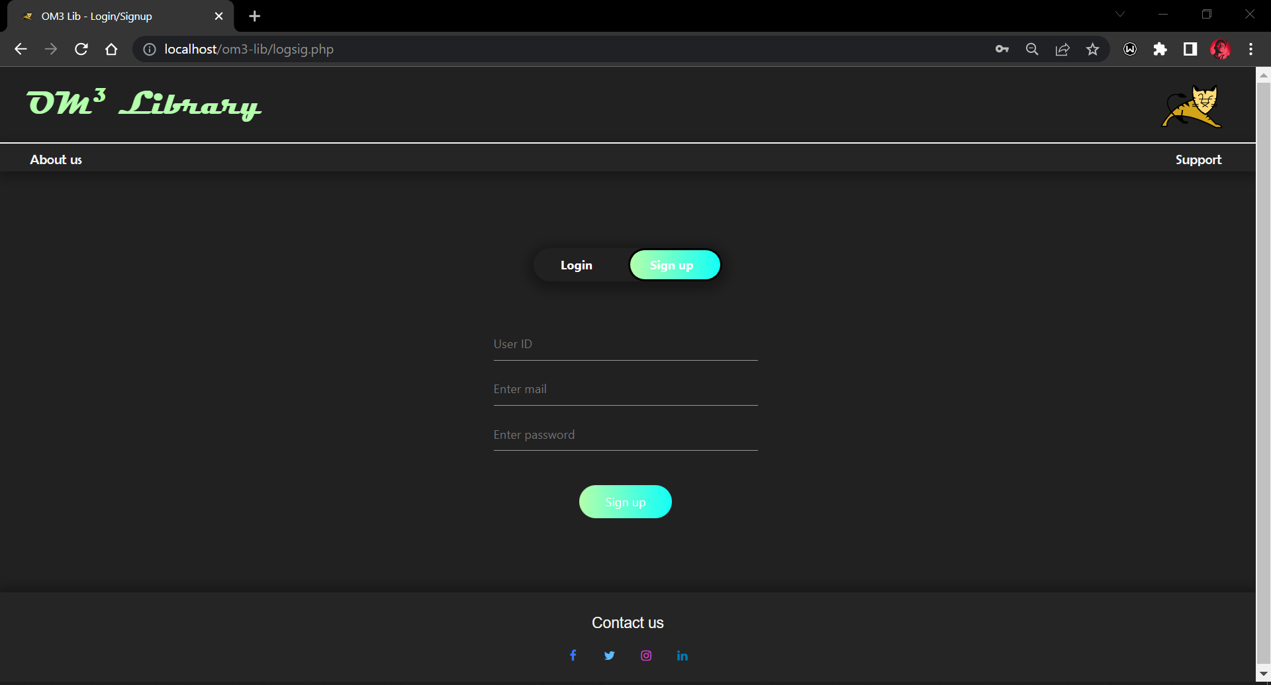

**Home** (home.php)

**Code:**

<?php

session_start();

if (empty($_SESSION['username'])) {

    $sname = $sid = $semail = $starid = $sbook = '';

} else {

    $sname = $_SESSION['username'];

    $ssid = $_SESSION['idno'];

    $sid = $_SESSION['idno'];

    $semail = $_SESSION['email'];

    $sbook = $_SESSION['book'];

}

$borbook = $retbook = '';

if (isset($_POST['returnsub'])) {

    if (empty($_SESSION['username'])) {

        echo "<script> window.location.href='logsig.php'; </script>";

    } else {

        $ssid = $_SESSION['idno'];

        if (empty($_POST['retbooknum'])) {

            echo "<script>alert('Enter a book number!')</script>";

        } else {

            $yes = 'yes';

            $no = 'no';

            $umm = 0;

            $retbook = $_POST['retbooknum'];

            $connect = new mysqli('sql6.freesqldatabase.com', 'sql6500064', 'k3rbF4wgQQ', 'sql6500064');

            $id_que = "SELECT * FROM books WHERE user='$ssid' AND id='$retbook' LIMIT 1";

            $resret = mysqli_query($connect, $id_que);

            $userret = mysqli_fetch_assoc($resret);

            if ($resret->num_rows > 0) {

                $query12 = "UPDATE `books` SET avail='$yes',user='$umm' where id='$retbook'";

                $query_run12 = mysqli_query($connect, $query12);

                if ($query_run12) {

                    $holdq2 = mysqli_query($connect, "UPDATE `logsig` SET hold='$umm' WHERE id='$ssid'");

                    if ($holdq2) {

                        $check_query = "SELECT * FROM logsig WHERE id='$ssid'";

                        $res = mysqli_query($connect, $check_query);

                        $resch = mysqli_num_rows($res);

                        if ($resch > 0) {

                            while ($row = mysqli_fetch_assoc($res)) {

                                $_SESSION['book'] = $row['hold'];

                            }

                            $sbook = $_SESSION['book'];

                            echo "<script>alert('Return Successful.')</script>";

                            echo "<script> window.location.href='home.php'; </script>";

                        }

                    }

                } else {

                    echo "<script>alert('Please enter the book num that you have borrowed.')</script>";

                }

            } else {

                echo "<script>alert('You don't have any book to return')</script>";

            }

            $retbook = $ssid = '';

            $connect->close();

        }

    }

}

if (isset($_POST['borrowsub'])) {

    if (empty($_SESSION['username'])) {

        echo "<script> window.location.href='logsig.php'; </script>";

    } else {

        $ssid = $_SESSION['idno'];

        if (empty($_POST['borbooknum'])) {

            echo "<script>alert('Enter a book number!')</script>";

        } else {

            $yes = 'yes';

            $no = 'no';

            $borbook = $_POST['borbooknum'];

            $connect = new mysqli('sql6.freesqldatabase.com', 'sql6500064', 'k3rbF4wgQQ', 'sql6500064');

            $id_query = "SELECT * FROM books WHERE user='$ssid' LIMIT 1";

            $res = mysqli_query($connect, $id_query);

            $user2 = mysqli_fetch_assoc($res);

            if ($res->num_rows > 0) {

                echo "<script>alert('Return the previous book!')</script>";

            } else {

                $user_check_query = "SELECT * FROM books WHERE id='$borbook' AND avail='$yes' LIMIT 1";

                $result = mysqli_query($connect, $user_check_query);

                $user = mysqli_fetch_assoc($result);

                if ($result->num_rows > 0) {

                    $query1 = "UPDATE `books` SET avail='$no',user='$ssid' where id='$borbook'";

                    $query_run1 = mysqli_query($connect, $query1);

                    if ($query_run1) {

                        $holdq = mysqli_query($connect, "UPDATE `logsig` SET hold='$borbook' WHERE id='$ssid'");

                        if ($holdq) {

                            $check_query = "SELECT * FROM logsig WHERE id='$ssid'";

                            $res = mysqli_query($connect, $check_query);

                            $resch = mysqli_num_rows($res);

                            if ($resch > 0) {

                                while ($row = mysqli_fetch_assoc($res)) {

                                    $_SESSION['book'] = $row['hold'];

                                }

                                $sbook = $_SESSION['book'];

                            }

                            echo "<script>alert('Borrow Successful.')</script>";

                            echo "<script> window.location.href='home.php'; </script>";

                        }

                    }

                } else {

                    echo "<script>alert('No books found with that book number / other user might having that book.')</script>";

                }

            }

            $borbook = $ssid = '';

            $connect->close();

        }

    }

}

?>

<!DOCTYPE html>

<html lang="en">

<head>

    <meta charset="UTF-8">

    <meta http-equiv="X-UA-Compatible" content="IE=edge">

    <meta name="viewport" content="width=device-width, initial-scale=1.0">

    <link rel="icon" type="image/x-icon" href="https://www.logo.wine/a/logo/Apache_Tomcat/Apache_Tomcat-Logo.wine.svg">

    <link rel="stylesheet" href="./css/ind.css">

    <link rel="stylesheet" href="https://cdnjs.cloudflare.com/ajax/libs/font-awesome/4.7.0/css/font-awesome.min.css">

    <link rel="stylesheet" href="https://cdn.jsdelivr.net/npm/bootstrap@4.3.1/dist/css/bootstrap.min.css" integrity="sha384-ggOyR0iXCbMQv3Xipma34MD+dH/1fQ784/j6cY/iJTQUOhcWr7x9JvoRxT2MZw1T" crossorigin="anonymous">

    <link href="https://cdn.jsdelivr.net/npm/bootstrap@5.0.2/dist/css/bootstrap.min.css" rel="stylesheet" integrity="sha384-EVSTQN3/azprG1Anm3QDgpJLIm9Nao0Yz1ztcQTwFspd3yD65VohhpuuCOmLASjC" crossorigin="anonymous">

    <script src="https://cdn.jsdelivr.net/npm/bootstrap@5.0.2/dist/js/bootstrap.bundle.min.js" integrity="sha384-MrcW6ZMFYlzcLA8Nl+NtUVF0sA7MsXsP1UyJoMp4YLEuNSfAP+JcXn/tWtIaxVXM" crossorigin="anonymous"></script>

    <script src="https://code.jquery.com/jquery-3.3.1.slim.min.js" integrity="sha384-q8i/X+965DzO0rT7abK41JStQIAqVgRVzpbzo5smXKp4YfRvH+8abtTE1Pi6jizo" crossorigin="anonymous"></script>

    <script src="https://cdn.jsdelivr.net/npm/popper.js@1.14.7/dist/umd/popper.min.js" integrity="sha384-UO2eT0CpHqdSJQ6hJty5KVphtPhzWj9WO1clHTMGa3JDZwrnQq4sF86dIHNDz0W1" crossorigin="anonymous"></script>

    <title>OM3 Lib - Home</title>

</head>

<body id="body" class="container-fluid">

    <header class="container-fluid">

        <span>

            <h1 class="mt-4 mb-4" style="font-size:270%; font-family:Magneto; color:#b3ffab;margin-left:20px ; text-align:left;">

                OM<sup><small>3</small></sup> Library <img width="130" src="https://www.logo.wine/a/logo/Apache_Tomcat/Apache_Tomcat-Logo.wine.svg" align="right" style="margin:-15px 5px" /></h1>

        </span>

    </header>

    <ul>

        <li style="float:left;">

            <a id="anav" href="#" data-toggle="modal" data-target="#modal1">Books List</a>

        </li>

        <p style="float:left;margin: 0px 5px;">|</p>

        <li style="float:left;">

            <a id="anav" href="support.php" target="_blank">Support</a>

        </li>

        <li style="float:right;margin-right: 35px;">

            <?php

            if (isset($_SESSION['username'])) {

                echo "

                <a id='anav' href='logout.php' title='Sign out'>Log out</a>";

            } else if (!isset($_SESSION['username'])) {

                echo "

                <a id='anav' href='logsig.php' title='Sign in'>Log in</a>";

            }

            ?>

        </li>

        <p style="float:right;margin-right: 5px;">|</p>

        <li style="float:right;margin-right: 5px;">

            <a id="anav" href="#" data-toggle="modal" data-target="#modal4">Profile</a>

        </li>

    </ul>

    <div class="col-md-10 offset-1 text-center mt-5 pt-2">

        <a id="borret" class="btn btn-primary mr-2" href="#read1" role="button">Read</a>|<a id="borret" class="btn btn-primary ml-2 mr-2" href="#" data-toggle="modal" data-target="#modal2" role="button">Borrow</a>

        <!--<h1 id="he1" class=""><span>Welcome author!</span></h1>-->

    </div>

    <div class="wrap2 col-md-10 offset-1 mt-0 border-bottom border-secondary">

        <h2 class="sm-head2 mt-5 mb-5" style="font-family: Elephant;">Explore Om<small><b><sup>3</sup></b></small>

            Library and savour the beyond knowledge</h2>

        <div id="cfade" class="carousel slide carousel-fade mb-5" data-ride="carousel">

            <div class="carousel-inner">

                <div class="carousel-item active">

                    <img src="https://qphs.fs.quoracdn.net/main-qimg-ff43d86fb71e339b408f856481eb7ffe-lq" class="img-fluid d-block w-100 h-auto">

                    <div class="carousel-caption d-none d-md-block">

                        <p>Libraries store the energy that fuels the imagination.

                            They open up windows to the world and inspire us to explore and achieve,

                            and contribute to improving our quality of life.</p>

                    </div>

                </div>

                <div class="carousel-item">

                    <img src="https://qphs.fs.quoracdn.net/main-qimg-376b816e6be9c16bc3998f2001de1ba0-lq" class="d-block w-100">

                    <div class="carousel-caption d-none d-md-block">

                        <p>Everything you need for better future and success has already been written.

                            And guess what? All you have to do is go to the library.</p>

                    </div>

                </div>

                <div class="carousel-item">

                    <img src="https://qphs.fs.quoracdn.net/main-qimg-55e5a51996021cc43872bda00e1861dc-lq" class="d-block w-100">

                    <div class="carousel-caption d-none d-md-block">

                        <p>Nothing is pleasanter than exploring a library.</p>

                    </div>

                </div>

            </div>

            <a class="carousel-control-prev" href="#cfade" role="button" data-slide="prev">

                <span class="carousel-control-prev-icon" aria-hidden="true"></span>

                <span class="sr-only">Previous</span>

            </a>

            <a class="carousel-control-next" href="#cfade" role="button" data-slide="next">

                <span class="carousel-control-next-icon" aria-hidden="true"></span>

                <span class="sr-only">Next</span>

            </a>

        </div>

    </div>

    <div class="wrap2 col-md-10 offset-1 mt-0 border-bottom border-secondary">

        <h2 class="sm-head2 mt-5 mb-5" style="font-family: Elephant;">Top chart this week!</h2>

        <div class="card-deck mb-5">

            <div class="card border-0 bg-dark shadow rounded">

                <img class="card-img-top" src="https://qphs.fs.quoracdn.net/main-qimg-2399eb360969520dbe8087d3ce90a4fd-lq">

                <div class="card-body text-muted ">

                    <h4 class="card-title">PRIDE AND PREJUDICE</h4>

                    <h6 class="card-text ">Jane Austen</h6>

                </div>

            </div>

            <div class="card bg-dark border-0 shadow rounded">

                <img class="card-img-top" src="https://qphs.fs.quoracdn.net/main-qimg-23fea25c8677ce80e6d97b0cc50848f6-lq">

                <div class="card-body text-muted">

                    <h4 class="card-title">A STUDY IN SCARLET</h4>

                    <h6 class="card-text ">Sir Arthur Conan Doyle</h6>

                </div>

            </div>

            <div class="card bg-dark border-0 shadow rounded">

                <img class="card-img-top" src="https://qphs.fs.quoracdn.net/main-qimg-dc0c29381caff9a34310ed6be83ee2a0-lq">

                <div class="card-body text-muted">

                    <h4 class="card-title">DUNE</h4>

                    <h6 class="card-text fs-10">Frank Herbert</h6>

                </div>

            </div>

        </div>

    </div>

    <div id="read1" class="col-md-10 offset-1 mt-3 pb-5 border-bottom border-secondary">

        <section class="container-fluid d-flex">

            <div class="mt-5">

                <img height="450px" width="650px" src="https://qphs.fs.quoracdn.net/main-qimg-8a05d32faa5c334fa97f57e78ac297ae" alt="">

            </div>

            <div class="mt-5">

                <h2 style="font-family: Elephant;"> Read Articles</h2>

                <p>There are enough articles on this site to fill multiple books,

                    so it can sometimes be daunting to know where to start.

                    Below are what many consider to be the best articles that have been the most popular,

                    the most shared, or had the greatest effect on readers' lives.

                </p>

                <!-- articles accordion  -->

                <div class="accordion " id="accordionExample">

                    <div class="accordion-item border-0

                    ">

                        <h2 class="accordion-header " id="headingTwo">

                            <button id="but1" class="accordion-button  collapsed btn" type="button" data-bs-toggle="collapse" data-bs-target="#collapseOne" aria-expanded="false" aria-controls="collapseTwo">»&ensp;The Mark of a Servant Leader</button>

                        </h2>

                        <div id="collapseOne" class="accordion-collapse  collapse" aria-labelledby="headingTwo" data-bs-parent="#accordionExample">

                            <div class="accordion-body border-top border-secondary">“Meaningful relationships are what

                                matter most.

                                Showing the people around you that you care about them and that you're willing to put

                                them first,

                                is the mark of a true leader. Great leaders are vulnerable and unselfish. Ultimately,

                                they thrive by exhibiting this behavior and in so doing,

                                they earn the respect of all.”</div>

                        </div>

                    </div>

                    <div class="accordion-item border-0

                    ">

                        <h2 class="accordion-header" id="headingTwo">

                            <button id="but1" class="accordion-button collapsed btn" type="button" data-bs-toggle="collapse" data-bs-target="#collapseTwo" aria-expanded="false" aria-controls="collapseTwo">»&ensp;Shift Small Habits for Big Wins</button>

                        </h2>

                        <div id="collapseTwo" class="accordion-collapse collapse" aria-labelledby="headingTwo" data-bs-parent="#accordionExample">

                            <div class="accordion-body border-top border-secondary">"If you look at culture change as a

                                series of successful habit shifts,

                                the process of making it a reality starts to feel more achievable.

                                The impact of one small change across every team in your organization means hundreds or

                                thousands of interactions shifting to align with the culture you want.

                                It's not simple, but there are practical approaches you can take to move the needle."

                            </div>

                        </div>

                    </div>

                    <div class="accordion-item border-0

                    ">

                        <h2 class="accordion-header" id="headingTwo">

                            <button id="but1" class="accordion-button collapsed btn" type="button" data-bs-toggle="collapse" data-bs-target="#collapseThree" aria-expanded="false" aria-controls="collapseTwo">»&ensp;Take It Easy On Yourself</button>

                        </h2>

                        <div id="collapseThree" class="accordion-collapse collapse" aria-labelledby="headingTwo" data-bs-parent="#accordionExample">

                            <div class="accordion-body border-top border-secondary">"I don’t know about you, but balance

                                in life makes it easier.

                                If you like to chill a lot, try to mix it up with more hustle. If you’re the opposite,

                                try to find pauses during the day. The more you experiment, the better you understand my

                                intuition says."</div>

                        </div>

                    </div>

                </div>

            </div>

        </section>

    </div>

    <div id="read2" class="col-md-10 offset-1 mt-3 pb-5 mb-5 border-0 border-secondary">

        <section class="container-fluid d-flex">

            <div class="mt-5">

                <h2 style="font-family: Elephant;"> Read Newsletter</h2>

                <p>The ongoing Russian invasion of Ukraine has prompted the United States

                    and other western countries to impose hard sanctions of Russia and the European Union (EU)

                    has also been trying to decrease oil and gas imports from the country.

                </p>

                <!-- newsletter accordion -->

                <div class="accordion" id="accordionExample">

                    <div class="accordion-item border-0

                    ">

                        <h2 class="accordion-header" id="headingTwo">

                            <button id="but1" class="accordion-button collapsed btn btn-outline-info" type="button" data-bs-toggle="collapse" data-bs-target="#collapseFour" aria-expanded="false" aria-controls="collapseTwo">»&ensp;Plane carrying 126 people catches fire after crash

                                landing at US airport.</button>

                        </h2>

                        <div id="collapseFour" class="accordion-collapse collapse" aria-labelledby="headingTwo" data-bs-parent="#accordionExample">

                            <div class="accordion-body border-top border-secondary">A Red Air plane carrying 126 people

                                caught fire after crash landing at Miami International Airport.

                                The plane's landing gear collapsed as it approached the runway. As per officials,

                                three people suffered minor injuries in the crash landing and the subsequent fire.

                                A video posted online shows flames and smoke billowing out from near the wing of the

                                aircraft.</div>

                        </div>

                    </div>

                    <div class="accordion-item border-0

                    ">

                        <h2 class="accordion-header" id="headingTwo">

                            <button id="but1" class="accordion-button collapsed btn btn-outline-info" type="button" data-bs-toggle="collapse" data-bs-target="#collapseFive" aria-expanded="false" aria-controls="collapseTwo">»&ensp;David Warner becomes second cricketer to get out

                                stumped on 99 in ODI history.</button>

                        </h2>

                        <div id="collapseFive" class="accordion-collapse collapse" aria-labelledby="headingTwo" data-bs-parent="#accordionExample">

                            <div class="accordion-body border-top border-secondary">Australia opener David Warner on

                                Tuesday became the second cricketer

                                after former India batter VVS Laxman to get out stumped on 99 in ODI history.

                                Warner was stumped on 99(112) by Sri Lanka's Niroshan Dickwella on the bowling of

                                Dhananjaya de Silva

                                in the fourth ODI in Colombo. Laxman was stumped on 99(110) against West Indies in

                                Nagpur in 2002.

                            </div>

                        </div>

                    </div>

                    <div class="accordion-item border-0

                    ">

                        <h2 class="accordion-header" id="headingTwo">

                            <button id="but1" class="accordion-button collapsed btn btn-outline-info" type="button" data-bs-toggle="collapse" data-bs-target="#collapseSix" aria-expanded="false" aria-controls="collapseTwo">»&ensp;Musk's $44 bn deal in 'best interests' of Twitter &

                                its shareholders, says its board</button>

                        </h2>

                        <div id="collapseSix" class="accordion-collapse collapse" aria-labelledby="headingTwo" data-bs-parent="#accordionExample">

                            <div class="accordion-body border-top border-secondary">Twitter's board has recommended that

                                shareholders vote in favour of the proposed

                                $44 billion sale of the company to billionaire Elon Musk, a regulatory filing showed on Tuesday. The social media giant's board of directors has unanimously determined that the merger

agreement is advisable and in the best interests of Twitter and its stockholders", the filing showed. </div>

                        </div>

                    </div>

                </div>

            </div>

            <div class="mt-5">

                <img height="500px" width="700px" src="https://qphs.fs.quoracdn.net/main-qimg-c2a463559c283ff084e82bc127ad1201">

            </div>

        </section>

    </div>

    <div class="modal fade" id="modal1" tabindex="1" role="dialog" aria-labelledby="modal1title" aria-hidden="true">

        <div class="modal-dialog modal-lg modal-dialog-centered text-center" role="document" id="mod1">

            <div class="modal-content text-center" id="moc1">

                <div class="modal-header text-center border-0 align-center" id="moh1">

                    <button type="button" id="mod1but" class="close" data-dismiss="modal" aria-label="Close">

                        <span aria-hidden="true">&times;</span>

                    </button>

                </div>

                <!--   <h3 class="title" id="modal1ltitle">Books List</h3>-->

                <div class="modal-body">

                    <div id="bbor" class="mt-3 ml-3 mb-4 mr-3">

                        <table id="tb1" class="table table-borderless text-dark col-md-10 offset-1">

                            <thead>

                                <h4 id="bna" class="mb-3">Romantic</h4>

                            </thead>

                            <tr>

                                <th scope="col">Book No.</th>

                                <th scope="col">Name</th>

                                <th scope="col">Author</th>

                                <th scope="col">Availablity</th>

                            </tr>

                            <?php

                            $conn = mysqli_connect('sql6.freesqldatabase.com', 'sql6500064', 'k3rbF4wgQQ', 'sql6500064');

                            $tab = "SELECT id,bname,author,avail FROM books WHERE genre='rom' ORDER BY id ASC";

                            $re = $conn->query($tab);

                            if ($re->num_rows > 0) {

                                while ($ro = $re->fetch_assoc()) {

                                    echo "<tr style='font-size:90%;'><td>" . $ro['id'] . "</td><td>" . $ro['bname'] . "</td><td>" . $ro['author'] . "</td><td>" . $ro['avail'] . "</td></tr>";

                                }

                                echo "</tbody>";

                                echo "</table>";

                            }

                            $conn->close();

                            ?>

                        </table>

                    </div>

                    <div id="bbor" class="mt-5 ml-3 mb-4 mr-3">

                        <table id="tb1" class="table table-borderless text-dark col-md-10 offset-1">

                            <thead>

                                <h4 id="bna" class="mb-3">Fantasy</h4>

                            </thead>

                            <tr>

                                <th scope="col">Book No.</th>

                                <th scope="col">Name</th>

                                <th scope="col">Author</th>

                                <th scope="col">Availablity</th>

                            </tr>

                            <?php

                            $conn = mysqli_connect('sql6.freesqldatabase.com', 'sql6500064', 'k3rbF4wgQQ', 'sql6500064');

                            $tab = "SELECT id,bname,author,avail FROM books WHERE genre='fan' ORDER BY id ASC";

                            $re = $conn->query($tab);

                            if ($re->num_rows > 0) {

                                while ($ro = $re->fetch_assoc()) {

                                    echo "<tr style='font-size:90%;'><td>" . $ro['id'] . "</td><td>" . $ro['bname'] . "</td><td>" . $ro['author'] . "</td><td>" . $ro['avail'] . "</td></tr>";

                                }

                                echo "</tbody>";

                                echo "</table>";

                            }

                            $conn->close();

                            ?>

                        </table>

                    </div>

                    <div id="bbor" class="mt-5 ml-3 mb-4 mr-3">

                        <table id="tb1" class="table table-borderless text-dark col-md-10 offset-1">

                            <thead>

                                <h4 id="bna" class="mb-3"><em><b>Science Fiction</b></em></h4>

                            </thead>

                            <tr>

                                <th scope="col">Book No.</th>

                                <th scope="col">Name</th>

                                <th scope="col">Author</th>

                                <th scope="col">Availablity</th>

                            </tr>

                            <?php

                            $conn = mysqli_connect('sql6.freesqldatabase.com', 'sql6500064', 'k3rbF4wgQQ', 'sql6500064');

                            $tab = "SELECT id,bname,author,avail FROM books WHERE genre='scfi' ORDER BY id ASC";

                            $re = $conn->query($tab);

                            if ($re->num_rows > 0) {

                                while ($ro = $re->fetch_assoc()) {

                                    echo "<tr style='font-size:90%;'><td>" . $ro['id'] . "</td><td>" . $ro['bname'] . "</td><td>" . $ro['author'] . "</td><td>" . $ro['avail'] . "</td></tr>";

                                }

                                echo "</tbody>";

                                echo "</table>";

                            }

                            $conn->close();

                            ?>

                        </table>

                    </div>

                </div>

            </div>

            <div class="modal-footer border-0">

                <!--  <button type="button" class="btn btn-secondary" data-dismiss="modal">Close</button>

                    <button type="button" class="btn btn-primary">Save changes</button>

                  -->

            </div>

        </div>

    </div>

    <div class="modal fade" id="modal2" tabindex="1" role="dialog" aria-labelledby="modal2title" aria-hidden="true">

        <div class="modal-dialog modal-md modal-dialog-centered text-center" role="document" id="mod2">

            <div class="modal-content text-center" id="moc2">

                <div class="modal-header text-center border-0 align-center" id="moh2">

                    <h3 class="title" id="modal2ltitle">Borrow Books</h3>

                    <button type="button" id="mod2but" class="close" data-dismiss="modal" aria-label="Close">

                        <span aria-hidden="true">&times;</span>

                    </button>

                </div>

                <p id="mutedtext">Check the book numbers in books list menu to borrow. To return the book got to profile.</p>

                <div class="modal-body">

                    <div id="baid" class="text-left ml-3">

                        Name: &emsp;&ensp;<span style="color: #000;font-weight:bold;"><?php echo $sname ?></span><br>

                        ID no:&emsp;&emsp;<span style="color: #000;font-weight:bold;"><?php echo $sid ?></span><br>

                    </div>

                    <div class="text-left">

                        <form method="post" name="borrowbooks" id="borrowbooks" action="home.php">

                            <label for="borbooknum" style="font-size:90%;" id="baid" class="text-left ml-3">Book no:</label><br>

                            <input id="borrnum" type="tel" name="borbooknum" class="col-md-10 offset-1 mb-2 mt-1" minlength="8" maxlength="8" placeholder="Enter book number to borrow" value="<?php echo $retbook ?>">

                            <p id="prompts" class="ml-5" style="font-size:80%;"></p>

                            <input type="submit" style="margin-top:px" class="col-md-4 offset-4" id="borsub" name="borrowsub" value="Borrow">

                        </form>

                    </div>

                </div>

            </div>

        </div>

    </div>

    <div class="modal fade" id="modal4" tabindex="1" role="dialog" aria-labelledby="modal4title" aria-hidden="true">

        <div class="modal-dialog modal-mg modal-dialog-centered text-center" role="document" id="mod4">

            <div class="modal-content text-center" id="moc4">

                <div class="modal-header text-center border-0 align-center" id="moh4">

                    <h3 class="title" id="modal4ltitle">Profile</h3>

                    <button type="button" id="mod4but" class="close" data-dismiss="modal" aria-label="Close">

                        <span aria-hidden="true">&times;</span>

                    </button>

                </div>

                <p id="mutedtext" class="ml-3 mr-3">Check the books that are with you and return later. To borrow books go to borrow.</p>

                <div id="jaffa" class="modal-body">

                    <div id="baid" class="text-left ml-3">

                        Name: &emsp;&emsp;&emsp;&emsp;<span style="color: #000;font-weight:bold;"><?php echo $sname ?></span><br>

                        ID no:&emsp;&emsp;&emsp;&ensp;&emsp;<span style="color: #000;font-weight:bold;"><?php echo $sid ?></span><br>

                        E-mail Id:&emsp;&emsp;&emsp;<span style="color: #000;font-weight:bold;"><?php echo $semail ?></span><br>

                        Books with me:&ensp;<span style="color: #000;font-weight:bold;"><?php echo $sbook ?></span><br><br>

                    </div>

                    <div class="text-left">

                        <form method="post" name="returnbooks" id="returnbooks" action="home.php">

                            <input id="retnum" type="tel" class="col-md-10 offset-1" name="retbooknum" minlength="8" maxlength="8" placeholder="Enter book number to return" value="<?php echo $retbook ?>">

                            <p id="prompts" class="ml-5" style="font-size:80%;"></p><br>

                            <input type="submit" style="margin-top:px" class="col-md-4 offset-4 mb-2" id="retsub" name="returnsub" value="Return">

                        </form>

                    </div>

                </div>

            </div>

        </div>

    </div>

</body>

<footer style="background-color:#252525;">

    <div id="ff">

        <p id="foot1" align="middle">Contact us</p>

        <div align="middle">

            <a href="https://www.facebook.com/profile.php?id=100005647128902" target="_blank" title="Facebook" class="fa fa-facebook"></a>

            <a href="https://twitter.com/_v4vishnu_" target="_blank" class="fa fa-twitter" title="Twitter"></a>

            <a href="https://www.instagram.com/_v4vishnu_/" target="_blank" class="fa fa-instagram" title="Instagram"></a>

            <a href="https://www.linkedin.com/in/vishnu-m-6092811a7/" target="_blank" class="fa fa-linkedin" title="Linkedin"></a>

        </div>

    </div>

</footer>

</html>

**Output:**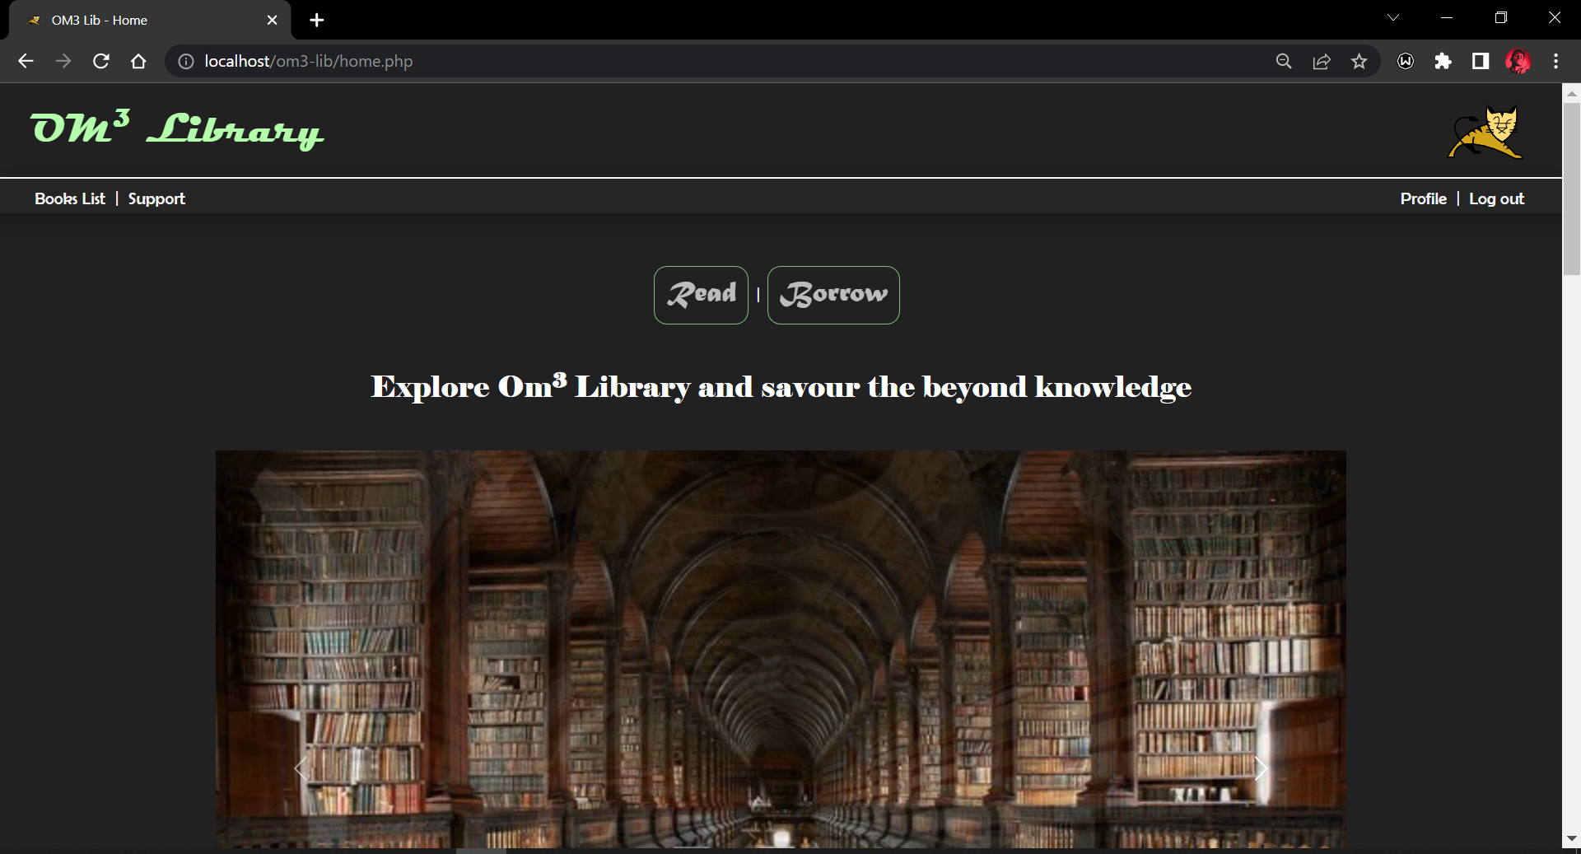 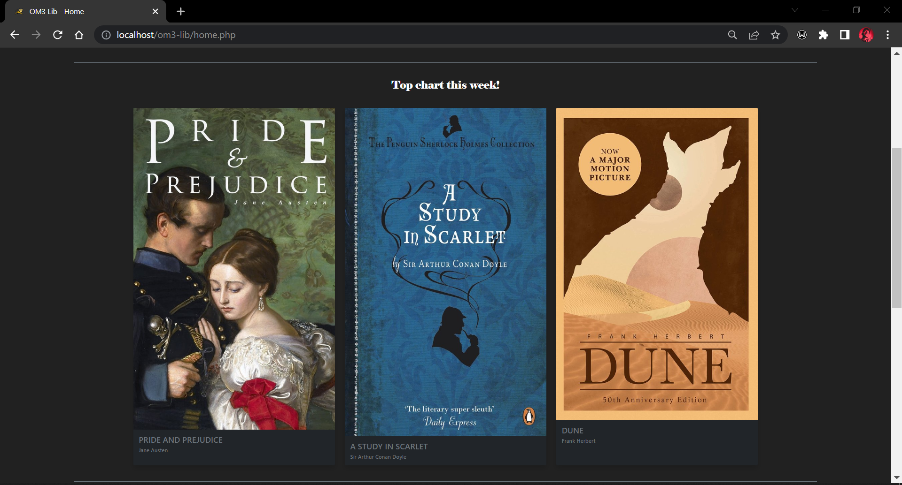 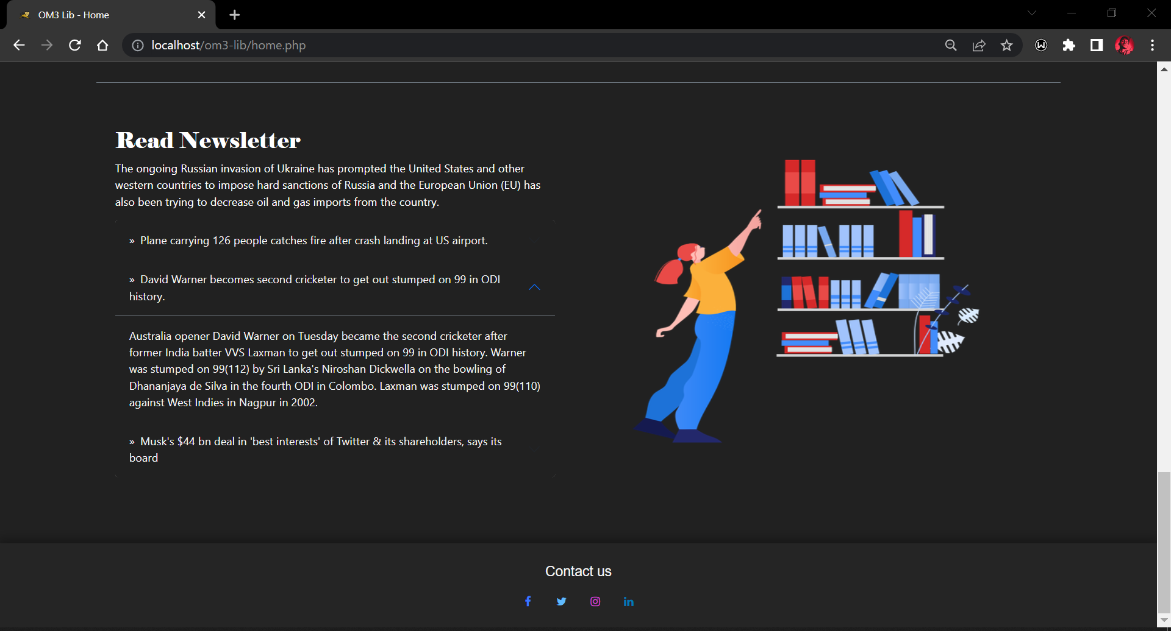

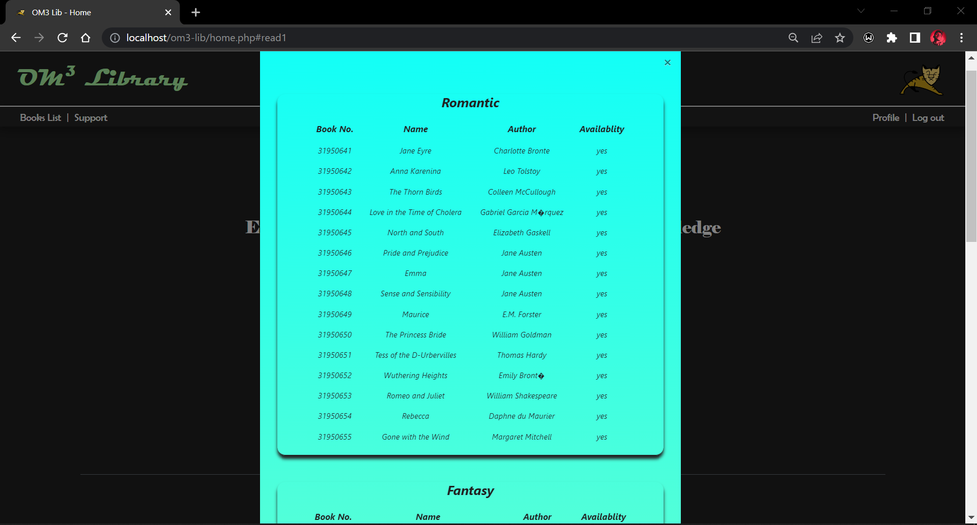 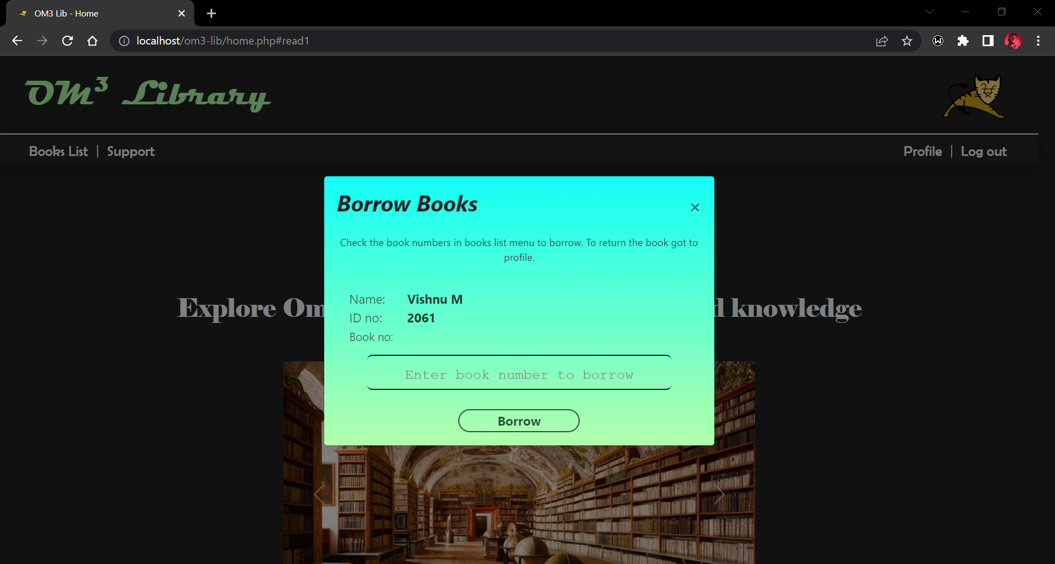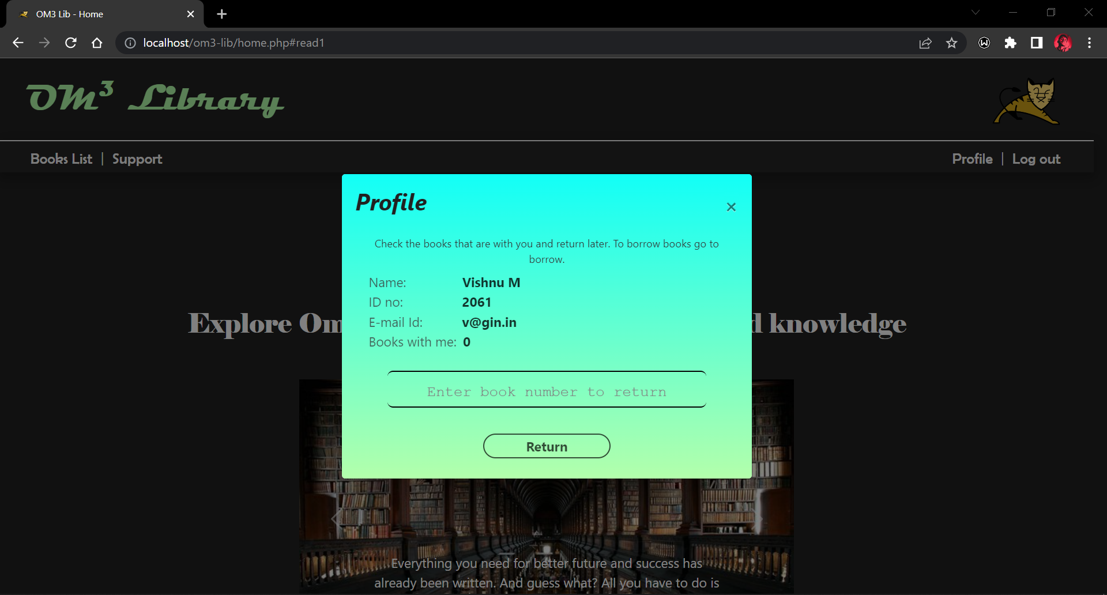

**Support** (support.php)

**Code:**

<?php

if (isset($_POST['ssend'])) {

    $hsname = $_POST['sname'];

    $hsmail = $_POST['semail'];

    $hssub = $_POST['ssubject'];

    $hstarea = $_POST['stextarea'];

    $conn = mysqli_connect('sql6.freesqldatabase.com', 'sql6500064', 'k3rbF4wgQQ', 'sql6500064');

    $htres = mysqli_query($conn, "INSERT INTO supp2(sname,semail,ssub,starea)values('$hsname','$hsmail','$hssub','$hstarea')");

    $conn->close();

    echo "<script>alert('Message sent, thank you for contacting us!')</script>";

    $hsname = $hsmail = $hssub = $hstarea = '';

    echo "<script> window.location.href='support.php'; </script>";

}

?>

<!DOCTYPE html>

<html lang="en">

<head>

    <meta charset="UTF-8">

    <meta http-equiv="X-UA-Compatible" content="IE=edge">

    <meta name="viewport" content="width=device-width, initial-scale=1.0">

    <link rel="stylesheet" href="https://cdn.jsdelivr.net/npm/bootstrap@4.4.1/dist/css/bootstrap.min.css" integrity="sha384-Vkoo8x4CGsO3+Hhxv8T/Q5PaXtkKtu6ug5TOeNV6gBiFeWPGFN9MuhOf23Q9Ifjh" crossorigin="anonymous">

    <link rel="icon" type="image/x-icon" href="https://www.logo.wine/a/logo/Apache_Tomcat/Apache_Tomcat-Logo.wine.svg">

    <link rel="stylesheet" href="./css/ind.css">

    <link href="http://fonts.cdnfonts.com/css/magneto" rel="stylesheet">

    <link href="http://fonts.cdnfonts.com/css/forte" rel="stylesheet">

    <link href="http://fonts.cdnfonts.com/css/berlin-sans-fb-demi" rel="stylesheet">

    <link rel="stylesheet" href="https://cdnjs.cloudflare.com/ajax/libs/font-awesome/4.7.0/css/font-awesome.min.css">

    <link rel="stylesheet" href="https://cdn.jsdelivr.net/npm/bootstrap@4.3.1/dist/css/bootstrap.min.css" integrity="sha384-ggOyR0iXCbMQv3Xipma34MD+dH/1fQ784/j6cY/iJTQUOhcWr7x9JvoRxT2MZw1T" crossorigin="anonymous">

    <script src="https://code.jquery.com/jquery-3.3.1.slim.min.js" integrity="sha384-q8i/X+965DzO0rT7abK41JStQIAqVgRVzpbzo5smXKp4YfRvH+8abtTE1Pi6jizo" crossorigin="anonymous"></script>

    <script src="https://cdn.jsdelivr.net/npm/popper.js@1.14.7/dist/umd/popper.min.js" integrity="sha384-UO2eT0CpHqdSJQ6hJty5KVphtPhzWj9WO1clHTMGa3JDZwrnQq4sF86dIHNDz0W1" crossorigin="anonymous"></script>

    <script src="https://cdn.jsdelivr.net/npm/bootstrap@4.3.1/dist/js/bootstrap.min.js" integrity="sha384-JjSmVgyd0p3pXB1rRibZUAYoIIy6OrQ6VrjIEaFf/nJGzIxFDsf4x0xIM+B07jRM" crossorigin="anonymous"></script>

    <title>OM3 Lib - Support</title>

</head>

<body id="body" class="container-fluid" style="animation-name: example;

animation-duration: 0.2s;

animation-iteration-count: 3;">

    <header class="container-fluid">

        <span>

            <h1 class="mt-4 mb-4" style="font-size:270%; font-family:Magneto; color:#b3ffab;margin-left:20px ; text-align:left;">

                OM<sup><small>3</small></sup> Library <img width="130" src="https://www.logo.wine/a/logo/Apache_Tomcat/Apache_Tomcat-Logo.wine.svg" align="right" style="margin:-15px 5px" /></h1>

        </span>

    </header>

    <ul>

        <li style="float:left;margin-left: -5px;">

            <a id="anav" href="index.html">About us</a>

        </li>

    </ul>

    <div style="width: 100%;">

        <div class="jack">

            <div class="form-box2">

                <div class="button-box2">

                    <h2 id="supporttitle" class="col-md-4 offset-4 ">Support</h2>

                    <form method="post" name="support" id="support" action="#">

                        <input type="text" name="sname" minlength="6" maxlength="50" class="input-field" placeholder="Enter your name" value="" required><br>

                        <input type="email" name="semail" minlength="5" maxlength="50" class="input-field" placeholder="Enter your mail" value="" required><br>

                        <input type="text" name="ssubject" minlength="5" maxlength="30" class="input-field" placeholder="Enter the subject" value="" required><br>

                        <textarea name="stextarea" class="input-field" rows="4" cols="91" align="middle" placeholder="Tell us about your problem" value="" required></textarea>

                        <input type="submit" style="margin-top:40px" class="col-md-2 offset-5 submit-btn" id="hsend" name="ssend" value="Send">

                    </form>

                </div>

            </div>

        </div>

    </div>

</body>

<footer style="background-color:#252525;">

    <div id="ff">

        <p id="foot1" align="middle">Contact us</p>

        <div align="middle">

            <a href="https://www.facebook.com/profile.php?id=100005647128902" target="_blank" title="Facebook" class="fa fa-facebook"></a>

            <a href="https://twitter.com/_v4vishnu_" target="_blank" class="fa fa-twitter" title="Twitter"></a>

            <a href="https://www.instagram.com/_v4vishnu_/" target="_blank" class="fa fa-instagram" title="Instagram"></a>

            <a href="https://www.linkedin.com/in/vishnu-m-6092811a7/" target="_blank" class="fa fa-linkedin" title="Linkedin"></a>

        </div>

    </div>

</footer>

</html>

**Output:**

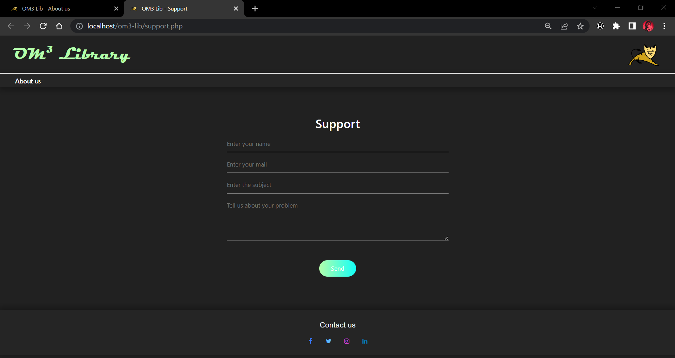

**Logout** (logout.php)

**Code:**

<?php

session_start();

session_destroy();

echo "<script> alert('Log out successful') </script>";

echo " <script> window.location.href='index.html'; </script> ";

?>